LidiPhone
Created on 16/04/2013
Table of Contents
SketchFlow Map 2
Navigation Screens 2
Home 3
Portrait 4
Landscape 5
AppList 6
Portrait 7
Landscape 8
New and Events 9
Search 10
Portrait 11
Landscape 12
Figures
Figure 1: SketchFlow Map 1
Figure 2: Home 2
Figure 3: Home, Portrait 3
Figure 4: Home, Landscape 4
Figure 5: AppList 5
Figure 6: AppList, Portrait 6
Figure 7: AppList, Landscape 7
Figure 8: New and Events 8
Figure 9: Search 9
Figure 10: Search, Portrait 10
Figure 11: Search, Landscape 11

SketchFlow Map
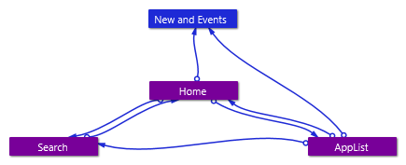
Figure 1: SketchFlow Map

Navigation Screens

Home
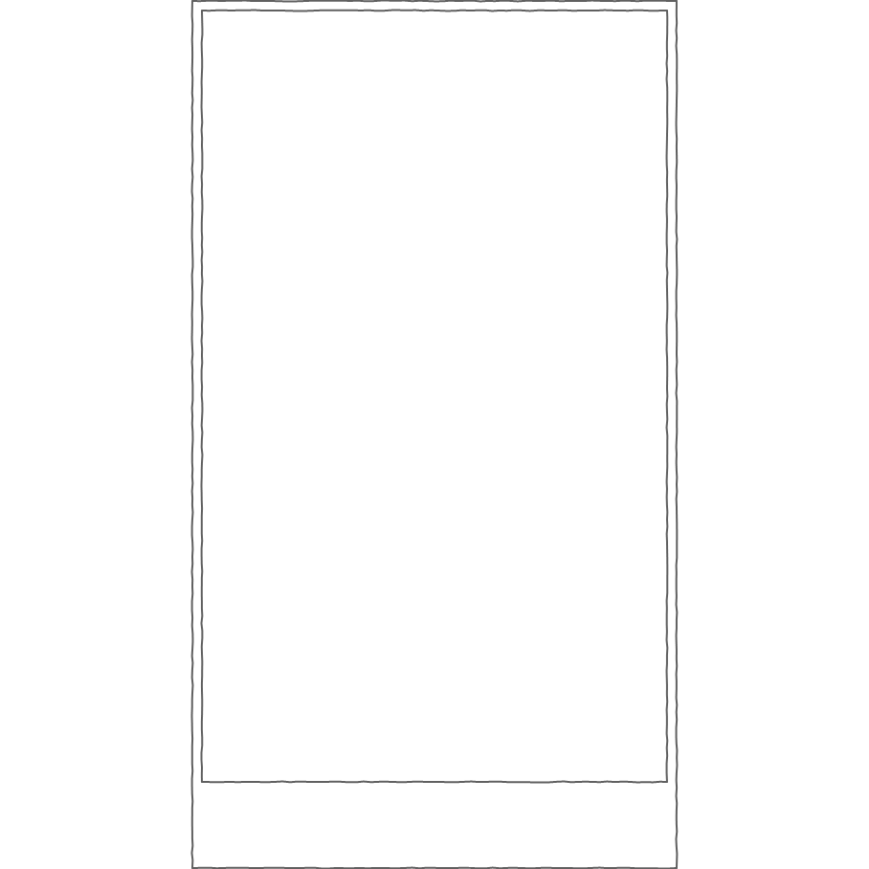
Figure 2: Home

Portrait
Figure 3: Home, Portrait

Landscape

Figure 4: Home, Landscape

AppList
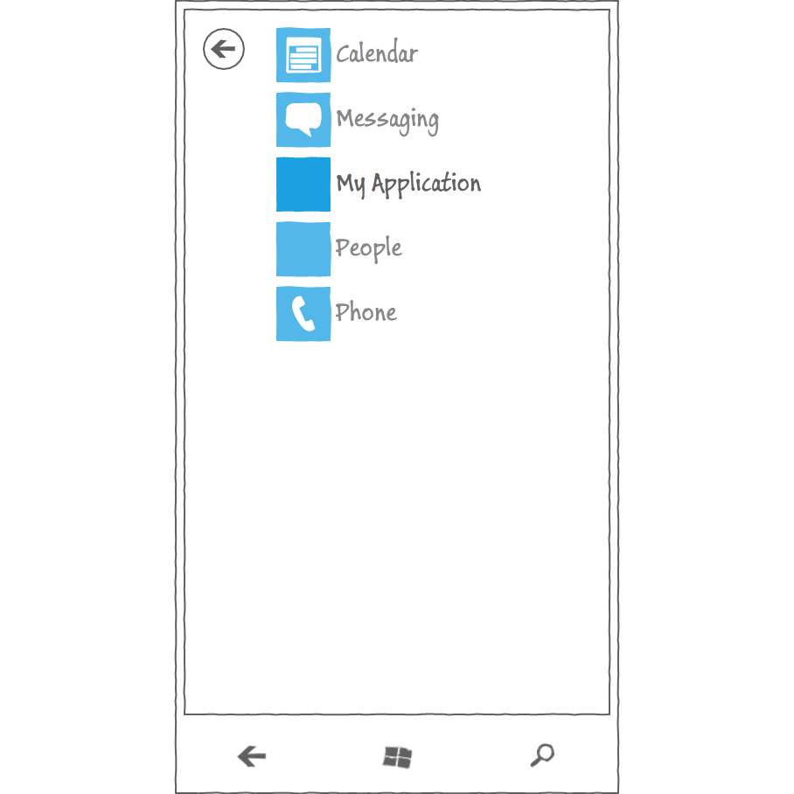
Figure 5: AppList

Portrait
Figure 6: AppList, Portrait

Landscape
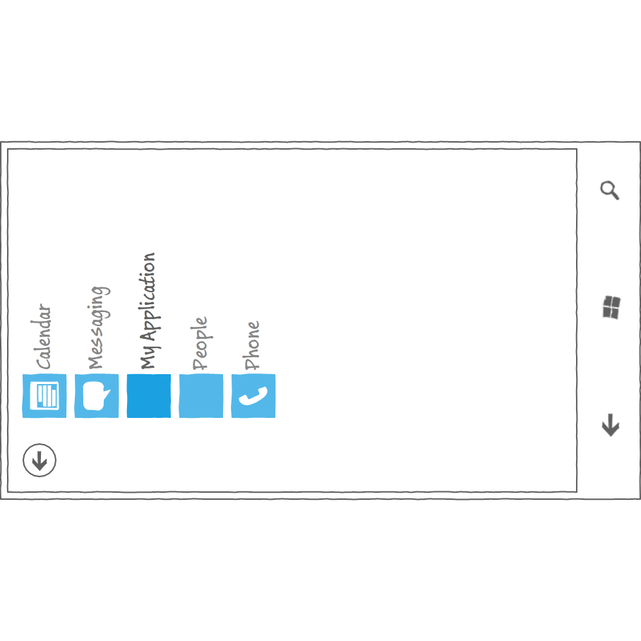
Figure 7: AppList, Landscape

New and Events
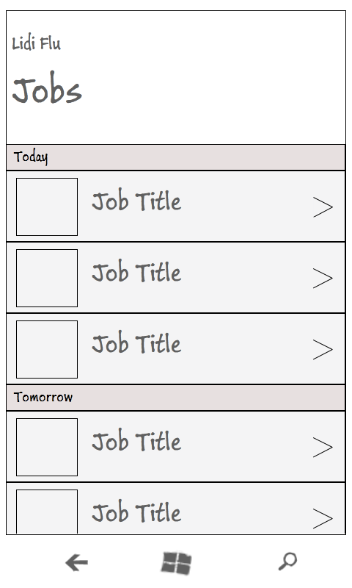
Figure 8: New and Events

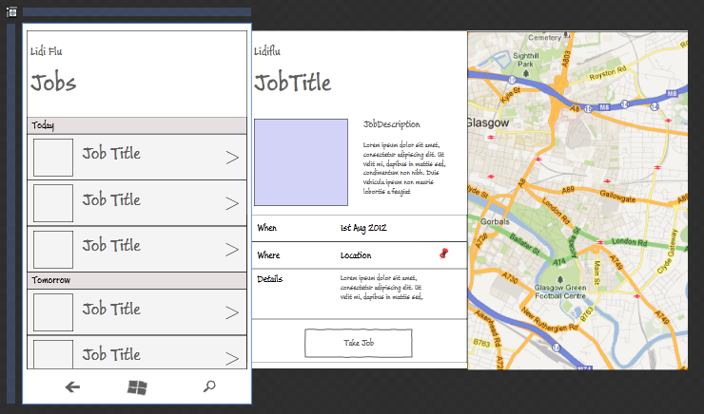

Search
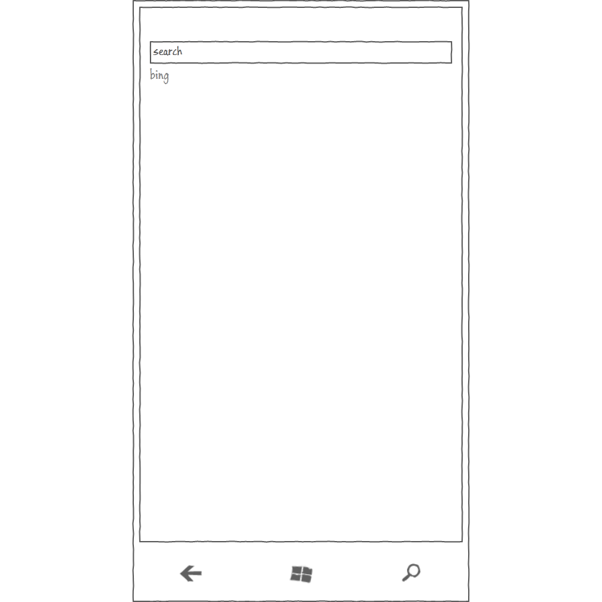
Figure 9: Search

Portrait
Figure 10: Search, Portrait

Landscape
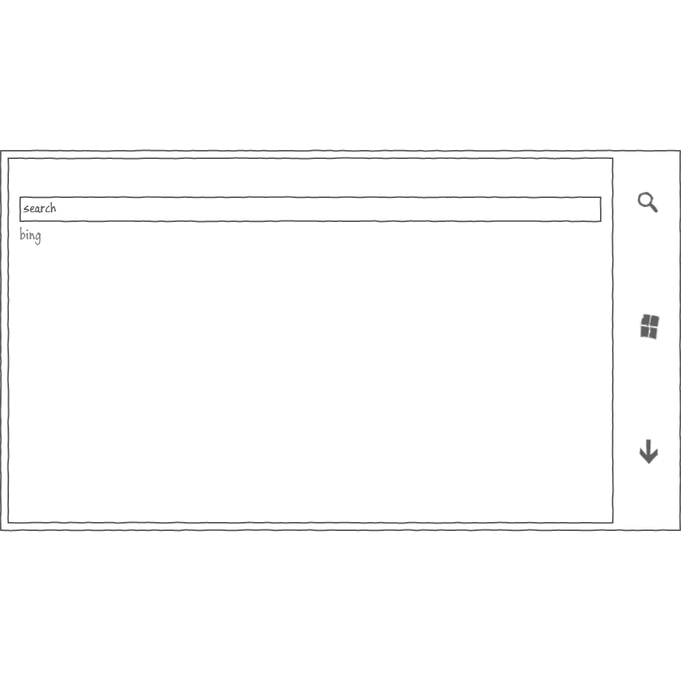
Figure 11: Search, Landscape

